NAME:Rishik JK
REG.NO :192511052

CSA1702-ARTIFICIAL INTELLIGENCE
LAB EXPERIMENT

- Sum of Integers from 1 to n

Aim
To write a Prolog program to find the sum of integers from 1 to n.

Algorithm
- Start the program.
- Define the base condition as sum_n(0,0).
- Check whether N is greater than 0.
- Subtract 1 from N.
- Recursively calculate the sum.
- Add N to the previous sum.
- Display the final sum.
- Stop.
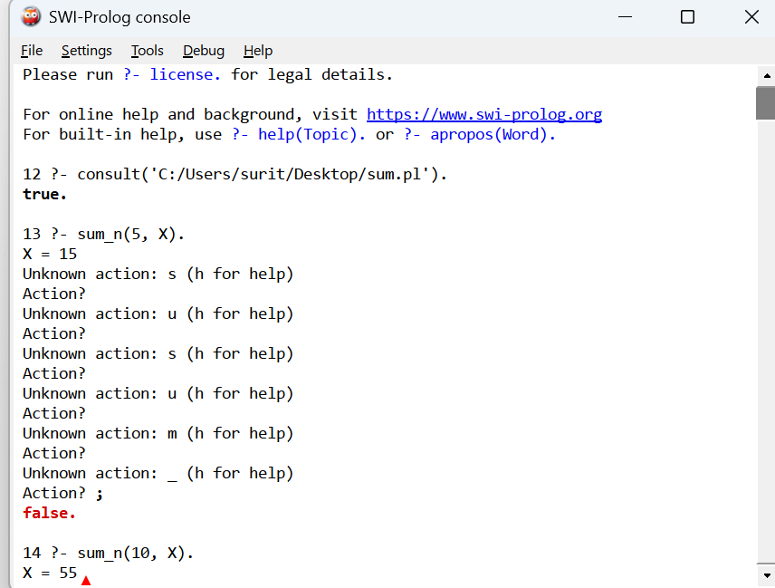

Result
Thus, the Prolog program to calculate the sum of integers from 1 to n was successfully implemented and executed. The sum of integers from 1 to 5 is 15.

